

Connectedness

©Bridge 86 Ltd. 2020

### CHIME

The CHIME framework for personal recovery

**Connectedness**

* Peer support and social groups
* Relationships
* Support from others
* Community

**Hope & optimism**

* Belief in recovery
* Motivation to

change

* Hope-inspiring

relationships

* Having dreams and aspirations

**Identity**

* Rebuilding positive sense of identity
* Overcoming

stigma

**Meaning**

* + Meaning in mental health experience
  + Meaningful life and social roles
  + Meaningful life and social goals

**Empowerment**

* Personal

responsibility

* Control over

life

* Focusing upon strengths



Leamy et al. 2011

©Bridge 86 Ltd. 2020

*“Connection is why we are here. We are hardwired to connect with others.”*

Brene Brown

### Recovery from what?



* + Loss of valued roles
  + Loss of connectedness
  + Loss of self
  + Loss of power
  + Loss of hope

©Bridge 86 Ltd. 2020

### Connectedness



in a recovery context

Being connected is associated with good mental health and wellbeing.

For most people, we thrive in social groups. Our connection with other people – and theirs with us

– makes us stronger.

The support we get and give makes us more resilient when bad times come along, and that needs to be nurtured.

©Bridge 86 Ltd. 2020

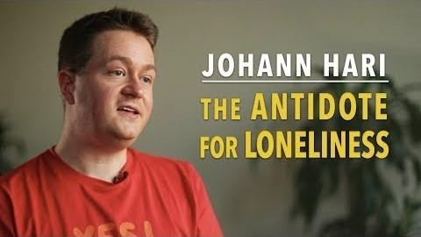

<https://www.youtube.com/watch?v=bC2Na1E3iVg>

©Bridge 86 Ltd. 2020

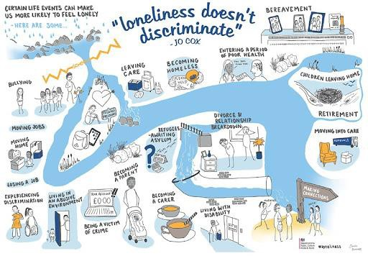

## Social isolation

*The inadequate quality and quantity of social relations with other people at the different levels where human interaction takes place (individual, group, community and the larger social environment).*

## Loneliness

*An emotional perception that can be experienced by individuals regardless of the breadth of their social networks.*

**Social recovery**



# Social recovery is perceived as a key dimension of mental health recovery, albeit a relatively neglected one.

**What is the place of social recovery in mental health alongside personal recovery?**

©Bridge 86 Ltd. 2020

### Connectedness

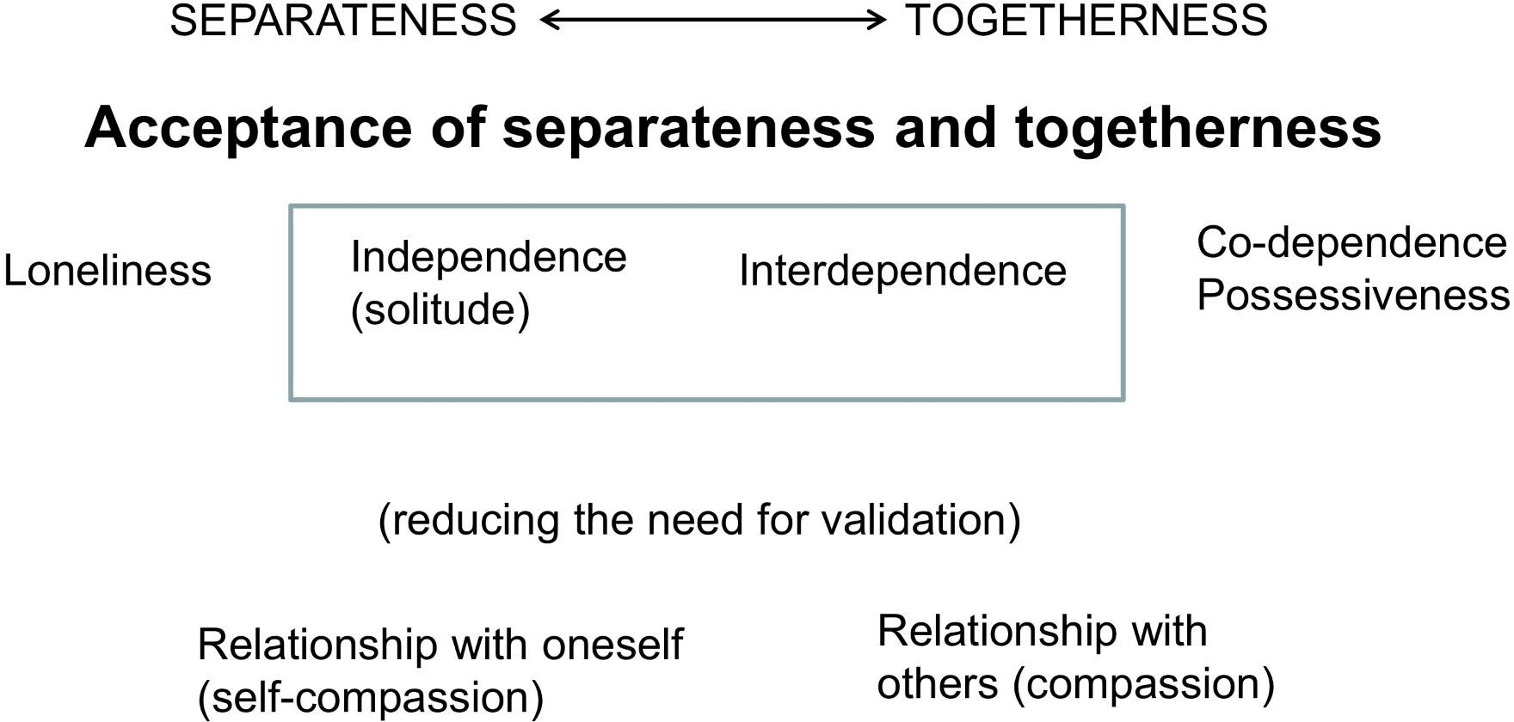

©Bridge 86 Ltd. 2020

### Connectedness



* We are both social and independent beings.
* We all need time apart. Periods of solitude can allow us to reflect on experiences and explore our creativity. But staying within reach is important.
* That said, feeling comfortable on our own probably directly relates to knowing we can easily reconnect with others.
* Hence, the goal in life is to maintain an **interdependent** existence i.e. grow up to become BOTH independent individuals AND people who can create and maintain relationships.

©Bridge 86 Ltd. 2020

### Networks of support



Consider the following questions:

* How connected are you?
* What do you do to get connected to people?
* Who listens to you when you need someone to talk to?
* With whom do you share good or bad news?
* When you need advice, who do you go to?
* When you have a problem, who do you turn to?

©Bridge 86 Ltd. 2020

### Networks of support



Mapping

Mapping your networks of support can be a good way to health-check your support system, and to take responsibility for making sure it’s robust.

People tend to find that they cope better with situations when they have a support system in place.

©Bridge 86 Ltd. 2020

### Networks of support

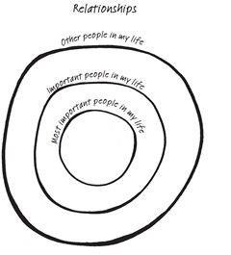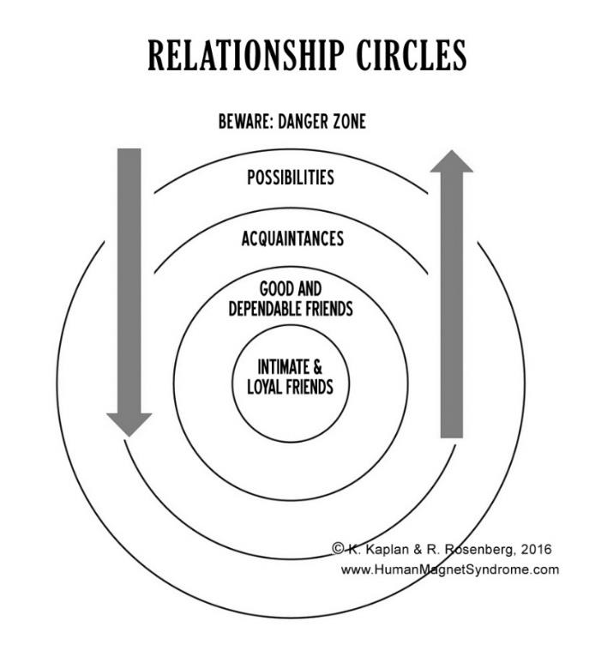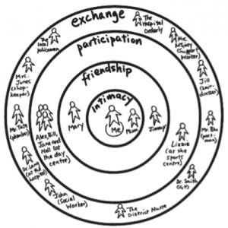

©Bridge 86 Ltd. 2020

**NETWORKS OF**

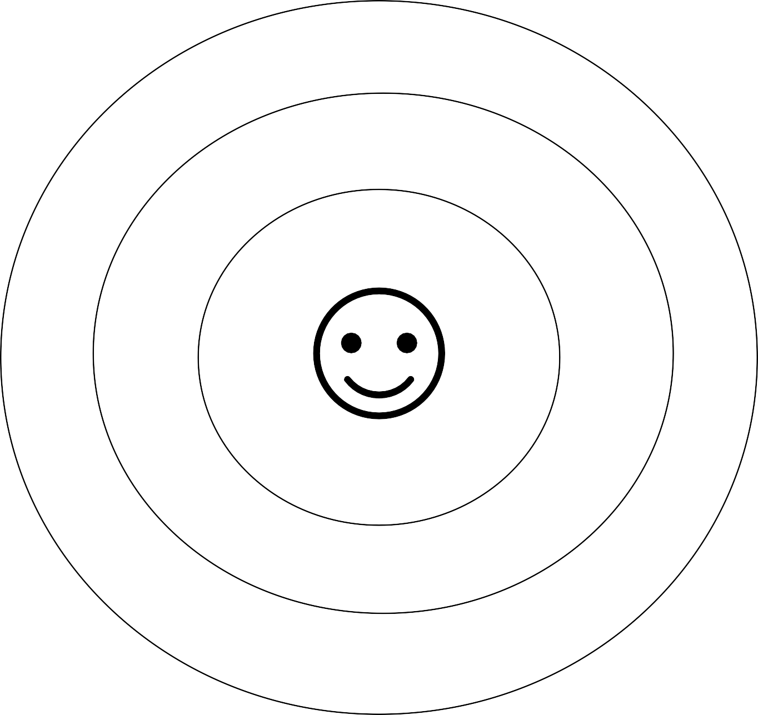

**SUPPORT**

**FAMILY & FRIENDS SERVICES/COMMUNITY GROUPS**

### Networks of support



Consider your networks of support:

* What does your diagram tell you about your ability to ask

for and receive support when you need it?

* Are you leaning too heavily on members of your support network or on a particular service?
* Do you have sufficient supports in place, or do you need to expand your network?
* What specific steps could you take to expand your

support network?

©Bridge 86 Ltd. 2020

### Beliefs

In life, behaviour follows belief. Everything we do is directly connected to what we believe is true. Complete the following sentence stems.

# I am…

Other people are… The world is…

Do you believe you are a person of worth, deserving of connection?

Does your belief take you closer towards or further away from people?



©Bridge 86 Ltd. 2020

