

Identity

©Bridge 86 Ltd. 2020

## CHIME

### The CHIME framework for personal recovery

**Connectedness**

* Peer support and social groups
* Relationships
* Support from others
* Community

**Hope & optimism**

* Belief in recovery
* Motivation to

change

* Hope-inspiring

relationships

* Having dreams and aspirations

**Identity**

* Rebuilding positive sense of identity
* Overcoming

stigma

**Meaning**

* + Meaning in mental health experience
  + Meaningful life and social roles
  + Meaningful life and social goals

**Empowerment**

* Personal

responsibility

* Control over

life

* Focusing upon strengths



Leamy et al. 2011

©Bridge 86 Ltd. 2020

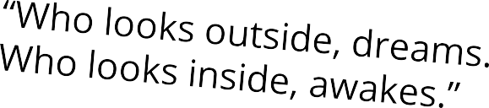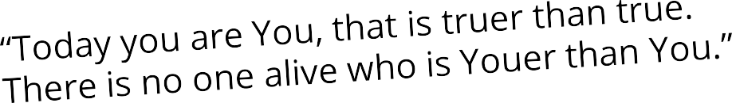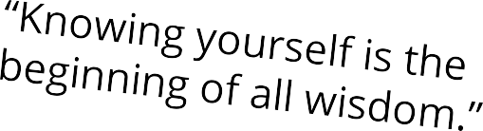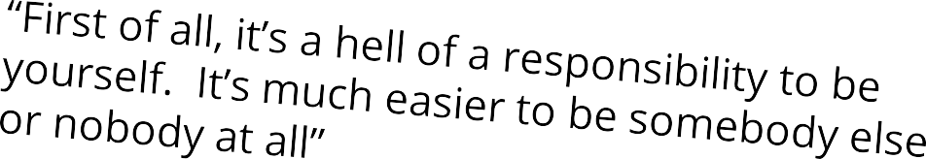

“Find out who you are and do it on

purpose.”

**~ DOLLY PARTON**

“Be yourself; everyone else

is already taken.”

**~ OSCAR WILDE**

“Insist on yourself. Never imitate.”

**~ RALPH WALDO EMERSON**

***Pick your favourite quote. What does it mean to you?***

## Identity



Definition

Identity is about our sense of self and who we are. This shapes our worldview and perceptions of reality, but it is about the groups we belong to and the people we do/don’t identify with. Identity is not fixed but fluid.

©Bridge 86 Ltd. 2020

*“Human beings are works in progress that mistakenly think they’re finished.”*

“The end of history illusion” - at any point along our personal journey, we tend to believe that who we are at that moment is the final destination of our becoming. Which, of course, is not only wrong but a source of much of our unhappiness.

**Identity**



***We*** get to reinvent ourselves over and over and over as we roll through life.

***We*** get to shake off identities and stroll into new ones.

***We*** get to decide who we are and who we are not.

©Bridge 86 Ltd. 2020

## Identity



**Consider the following questions:**

* + Do you feel like you have a strong sense of identity?
  + What do you feel makes you who you are?
  + What are some of the barriers to having a strong sense of identity?

©Bridge 86 Ltd. 2020

## Activity: Ten Words



If you had to describe yourself in ten words, what would they be?

1) 6)

2) 7)

3) 8)

4) 9)

5) 10)

Once you have a clear and honest idea of at least some of the things that you believe about yourself, ask yourself which of them propel you forward? Which hold you back? Did you always believe them about yourself? Have they changed over time? Where did these beliefs come from?

The key here is to start thinking about how you see yourself and how this

impacts your life. Some of your ideas about yourself are going to be

helpful, others not so much. Because if you don’t want to define yourself in this way, you don’t have to, it’s up to you!

©Bridge 86 Ltd. 2020

## Activity:



Complete the following sentences. Fill in the blanks with qualities

that describe how you tend to think, feel and act.

I am too

_

I shouldn’t be so

_ I should be more _

_

©Bridge 86 Ltd. 2020

## Identity

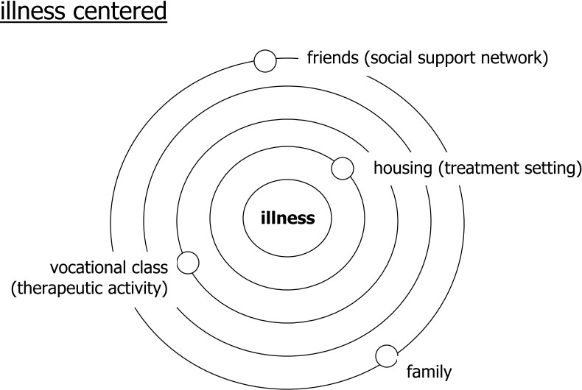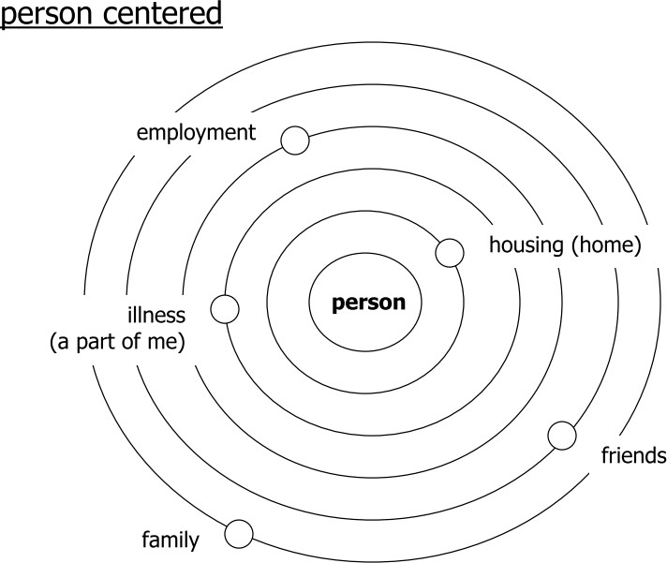

### Illness Centred vs Person Centred

Recovery is about discovering – or re-discovering – a sense of

personal identity, separate from illness or disability.

©Bridge 86 Ltd. 2020

## Identity - roles



Our mental illness might part of us, but it is not the whole of us.

An **illness centred perspective** can pervade everything we do. When we are unwell, it is difficult to feel positive about the future and it is easy to lose sight of our personal qualities and strengths.

When someone first gets ill, it can feel like it swallows them up. It can be hard to hold on to their sense of self and keep hope alive.

Hence, it is important to recognise all the roles we play and

recognise our value.

People’s identity is rooted in the roles they play, in what they

associate themselves with.

©Bridge 86 Ltd. 2020

## Identity - roles

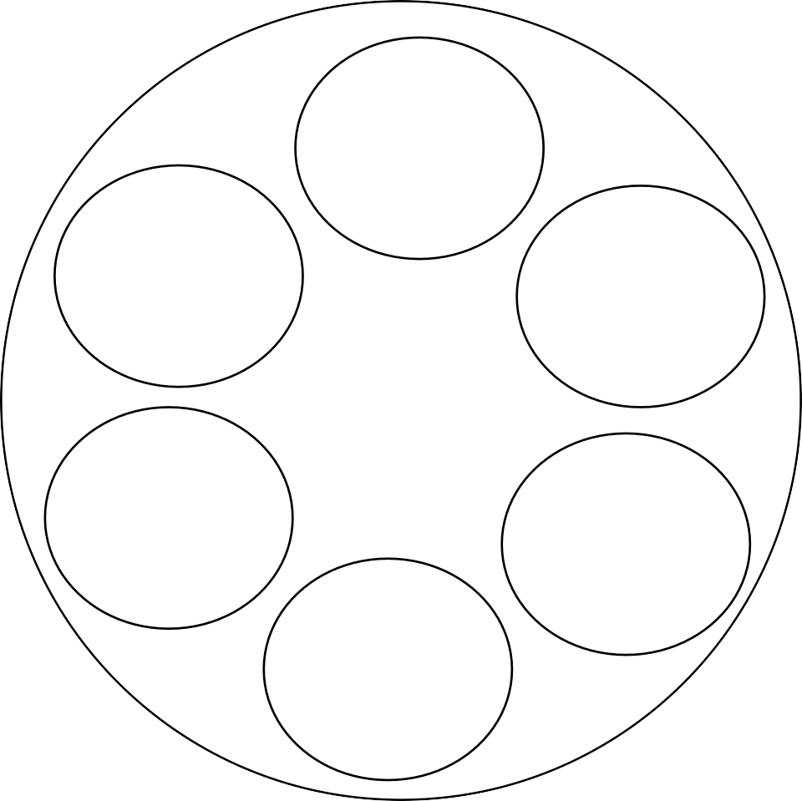

What roles do you play in life? Most people say that they need to be seen as more than just one thing. Many people say that developing or rediscovering an identity beyond that of being ‘a patient’ is the most important part of recovery.

illness

illness

person

©Bridge 86 Ltd. 2020

**DON'T**

**LET**

# YOUR

STRUGGLE

BECOME

# YOUR

IDENTITY

Te-a-:- off

,_ >-· r·ac- !I

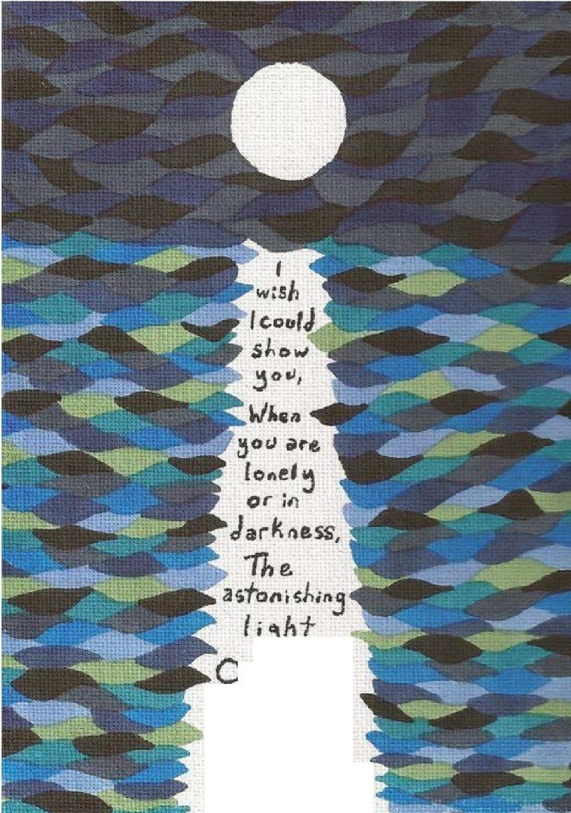

*i· j*

V, :1c,

*o wn ·*

***-be*** l *n* =,,

*-'Ha)i z*·



{BIG I}





