

Meaning

©Bridge 86 Ltd. 2020

*“Life is never made unbearable by circumstances but only by lack of meaning and purpose.”*

*Viktor Frankl*

# CHIME

The CHIME framework for personal recovery

**Connectedness**

* Peer support and social groups
* Relationships
* Support from others
* Community

**Hope & optimism**

* Belief in recovery
* Motivation to

change

* Hope-inspiring

relationships

* Having dreams and aspirations

**Identity**

* Rebuilding positive sense of identity
* Overcoming

stigma

**Meaning**

* + Meaning in mental health experience
  + Meaningful life and social roles
  + Meaningful life and social goals

**Empowerment**

* Personal

responsibility

* Control over

life

* Focusing upon strengths



Leamy et al. 2011

©Bridge 86 Ltd. 2020

# Meaning



in a recovery context

* + A large part of recovery is learning to make sense of what has happened to us as well as improving our wellbeing on a daily basis.
  + Meaning is the sense we make of our lives.
  + Happiness comes and goes. Meaning gives you

something to hold onto.

* + When you have found purpose in your life, the idea of becoming lost again will seem impossible, and that is because it will be.

©Bridge 86 Ltd. 2020

# Meaning making



We all find meaning in very different ways. Consider the following questions:

* + - What’s most important to you in your life?
    - Why do you care about these things?
    - Do you have any long-term goals?
    - Why are these goals important to you?
    - What does it mean to have a good life?
    - What does it mean to be a good person?
    - If I were looking back on your life, how would you want to be remembered?

©Bridge 86 Ltd. 2020

# What is your why?

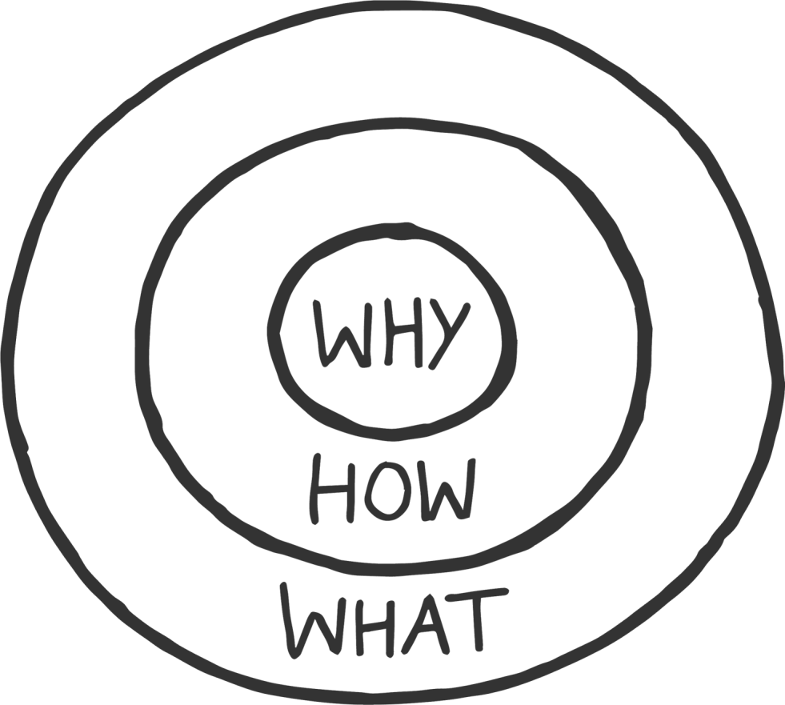

Your **why** will keep you going on days you don’t want to.

List as many reasons as possible, why you want to recover/get better.

*When your why is big enough you will find your how.*

©Bridge 86 Ltd. 2020

*“If you don’t design your own life plan, chances are you’ll*

*fall into someone else’s plan.*

*And guess what they have*

*planned for you? Not much.”*

*Jim Rohn*

# Create a life plan



Having a life plan means working towards clarifying your values (i.e., what matters to you), beliefs and priorities, and then applying them in your daily life.

What is significant about a life plan is that it can help you live your own life (i.e., take control).

Achieving a satisfying life requires knowledge, self-awareness, motivation and effort. It involves behaviours that promote wellbeing.

©Bridge 86 Ltd. 2020

*“The purpose of life is a life of purpose.”*

Robert Burns

**Why does purpose matter?**



Having a purpose is good for both you and the world. It drives you to make positive contributions in line with your own interests and strengths. And this pursuit gives your life direction and forward momentum; it motivates and guides your short-term goals and daily activities.

With a strong sense of purpose, you flourish, you enjoy a more meaningful life, are healthier and more resilient to setbacks, live more energetically, and feel good about

what you’ve accomplished.

©Bridge 86 Ltd. 2020

# Purpose pulse check



Think about yourself. How many of these things are true?

* + I look for ways to have positive effects on others’ lives.
  + I often reflect on my life goals and the kind of person I

want to be.

* + When I plan out my day, I consider how my activities

connect to what I want to accomplish with my life.

* + I often think about what I can offer the world, taking into account what the world needs as well as my personal strengths and interests.
  + I often think about what matters most to me and *why* it

matters.

©Bridge 86 Ltd. 2020

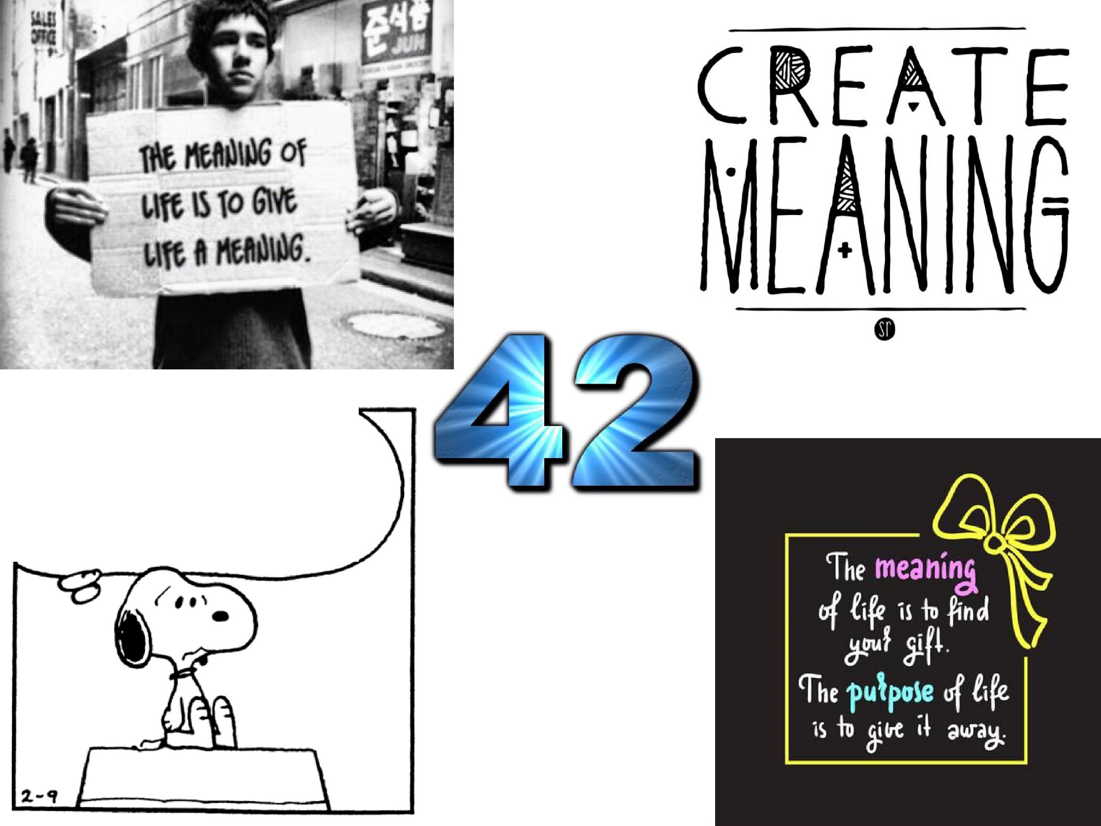

WHERE AM , I GOUJ6 ?

WHAT AM I *OOING* ?

WMAT *15* THE MEANf *N, G*

OF LIFE?